What datetime range does your data cover? How many rows are there total?

Datetime Range: From 2013-01-01 00:00:00 to 2013-01-31 23:59:59

Total Rows: 14776615

What are the field names? Give descriptions for each field.

Field Names:

Index(['medallion', 'hack_license', 'vendor_id', 'rate_code',

'store_and_fwd_flag', 'pickup_datetime', 'dropoff_datetime',

'passenger_count', 'trip_time_in_secs', 'trip_distance',

'pickup_longitude', 'pickup_latitude', 'dropoff_longitude',

'dropoff_latitude', 'hour'],

dtype='object')

Field Descriptions:

medallion : A unique identifier for the taxi

hack_license : A unique identifier for the taxi driver

pickup_datetime : Date and time of pickup

dropoff_datetime : Date and time of dropoff

Give some sample data for each field.

Sample Data:

medallion hack_license \

0 89D227B655E5C82AECF13C3F540D4CF4 BA96DE419E711691B9445D6A6307C170

1 0BD7C8F5BA12B88E0B67BED28BEA73D8 9FD8F69F0804BDB5549F40E9DA1BE472

2 0BD7C8F5BA12B88E0B67BED28BEA73D8 9FD8F69F0804BDB5549F40E9DA1BE472

3 DFD2202EE08F7A8DC9A57B02ACB81FE2 51EE87E3205C985EF8431D850C786310

4 DFD2202EE08F7A8DC9A57B02ACB81FE2 51EE87E3205C985EF8431D850C786310

vendor_id rate_code store_and_fwd_flag pickup_datetime \

0 CMT 1 N 2013-01-01 15:11:48

1 CMT 1 N 2013-01-06 00:18:35

2 CMT 1 N 2013-01-05 18:49:41

3 CMT 1 N 2013-01-07 23:54:15

4 CMT 1 N 2013-01-07 23:25:03

dropoff_datetime passenger_count trip_time_in_secs trip_distance \

0 2013-01-01 15:18:10 4 382 1.0

1 2013-01-06 00:22:54 1 259 1.5

2 2013-01-05 18:54:23 1 282 1.1

3 2013-01-07 23:58:20 2 244 0.7

4 2013-01-07 23:34:24 1 560 2.1

pickup_longitude pickup_latitude dropoff_longitude dropoff_latitude \

0 -73.978165 40.757977 -73.989838 40.751171

1 -74.006683 40.731781 -73.994499 40.750660

...

1 0

2 18

3 23

4 23

What MySQL data types / len would you need to store each of the fields?

MySQL Data Types:

medallion object

hack_license object

vendor_id object

rate_code int64

store_and_fwd_flag object

pickup_datetime datetime64[ns]

dropoff_datetime object

passenger_count int64

trip_time_in_secs int64

trip_distance float64

pickup_longitude float64

pickup_latitude float64

dropoff_longitude float64

dropoff_latitude float64

hour int32

dtype: object

Maximum String Lengths:

medallion 32

hack_license 32

vendor_id 3

rate_code 3

store_and_fwd_flag 3

pickup_datetime 19

...

dropoff_longitude 14

dropoff_latitude 14

hour 2

dtype: int64

What is the geographic range of your data (min/max - X/Y)?

Geographic Range:

Min Longitude: -2771.2854

Max Longitude: 112.40418

Min Latitude: -3547.9207

Max Latitude: 3310.3645

What is the average overall computed trip distance?

Average Trip Distance (Haversine): 12.178383325209287 miles

What are the distinct values for each field?

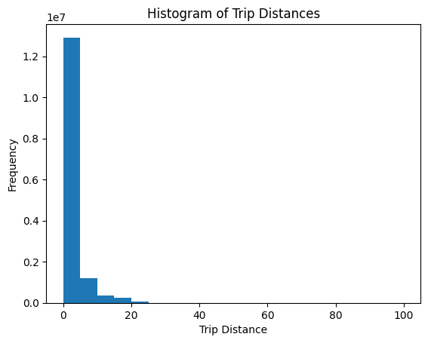

For other numeric types besides lat and lon, what are the min and max values?

Minimum and Maximum Values for Numeric Fields (excluding lat and lon):

rate_code passenger_count trip_time_in_secs trip_distance \

min 0 0 0 0.0

max 210 255 10800 100.0

pickup_longitude pickup_latitude dropoff_longitude dropoff_latitude \

min -2771.28540 -3547.9207 -2350.9556 -3547.9207

max 112.40418 3310.3645 2228.7375 3477.1055

hour

min 0

max 23

Create a chart which shows the average number of passengers each hour of the day.

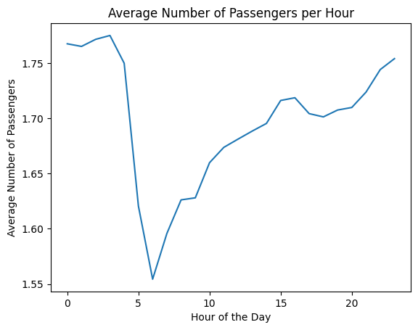

Repeat step 9 with the reduced dataset and compare the two charts.

